TASK – 2
Pre-requisites:
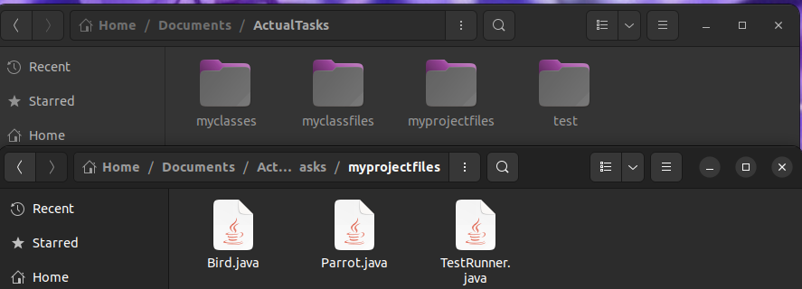
Ex – 1
Terminal:
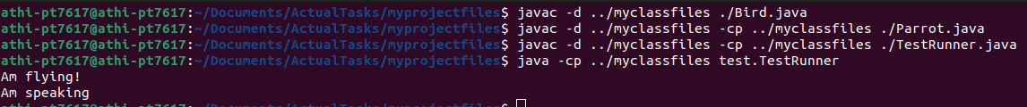
OutPut:
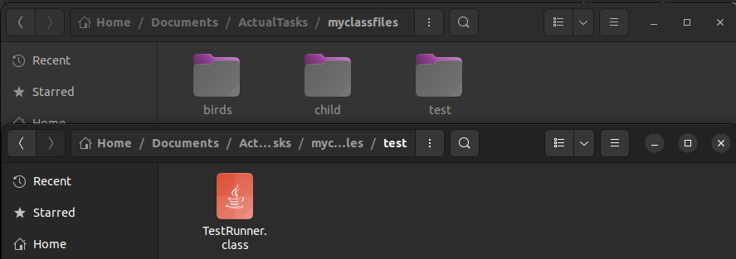
Ex – 2
Terminal:
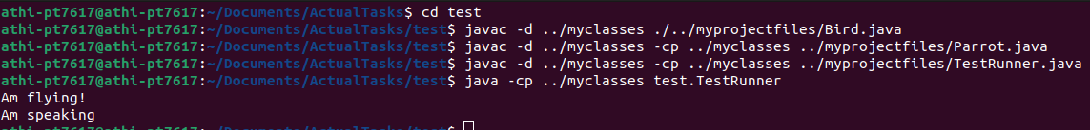
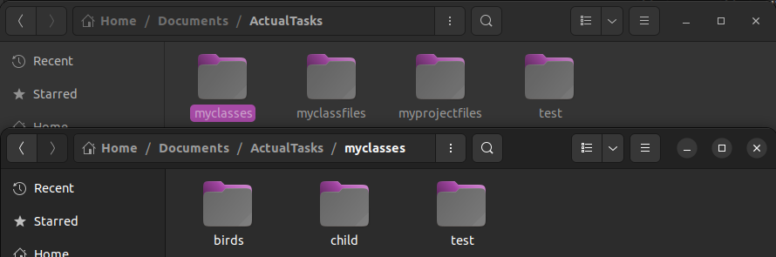
OutPut:
Ex – 3
Terminal:
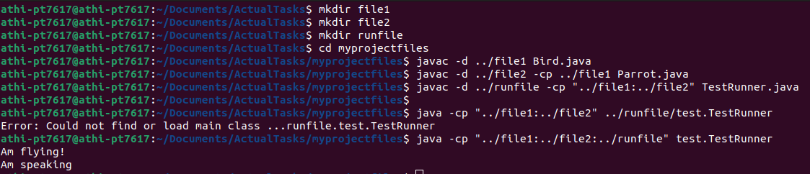
OutPut:
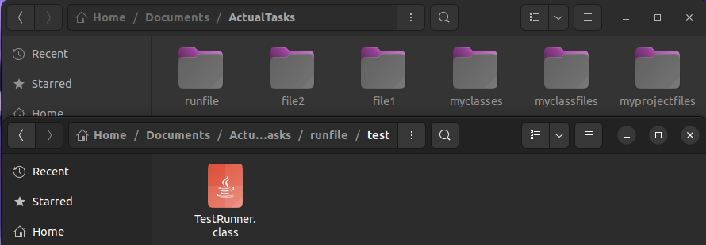
Ex – 4
Terminal:
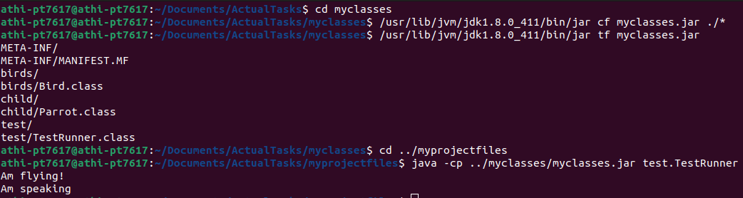
OutPut:
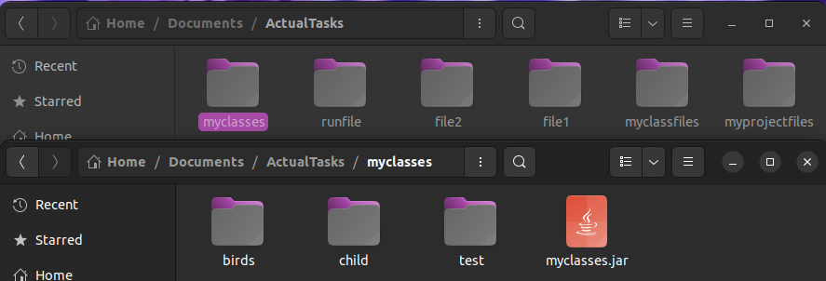

Ex – 5
Terminal:
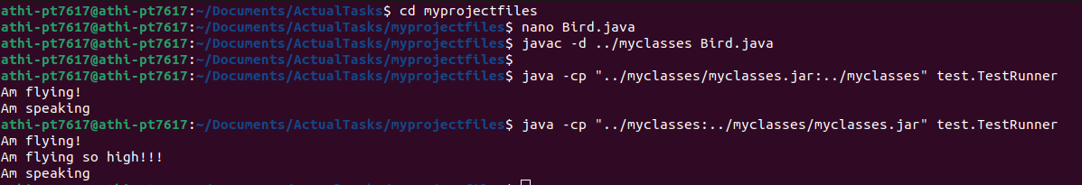
Bird.java:
